EXPERIMENT – 10

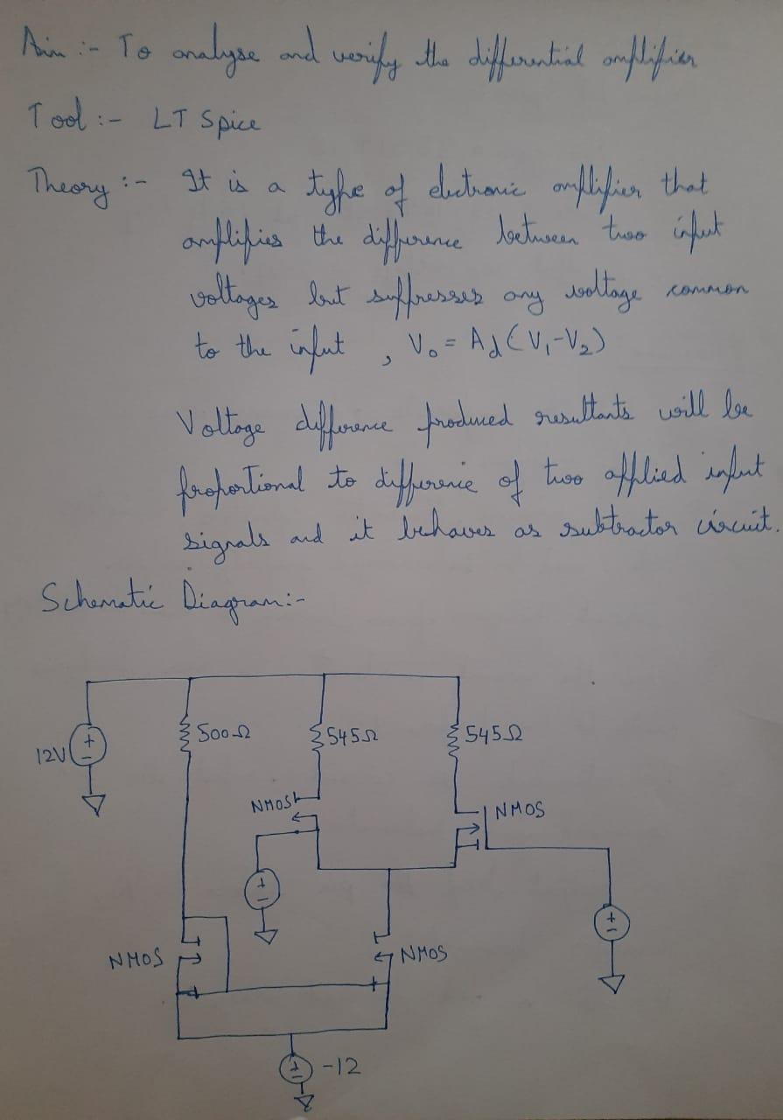

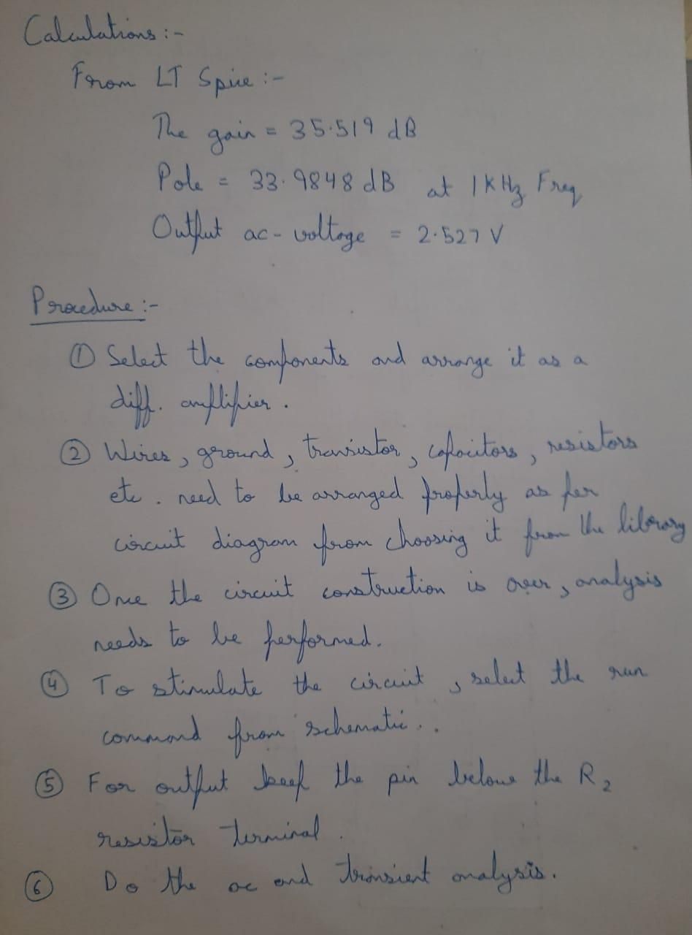

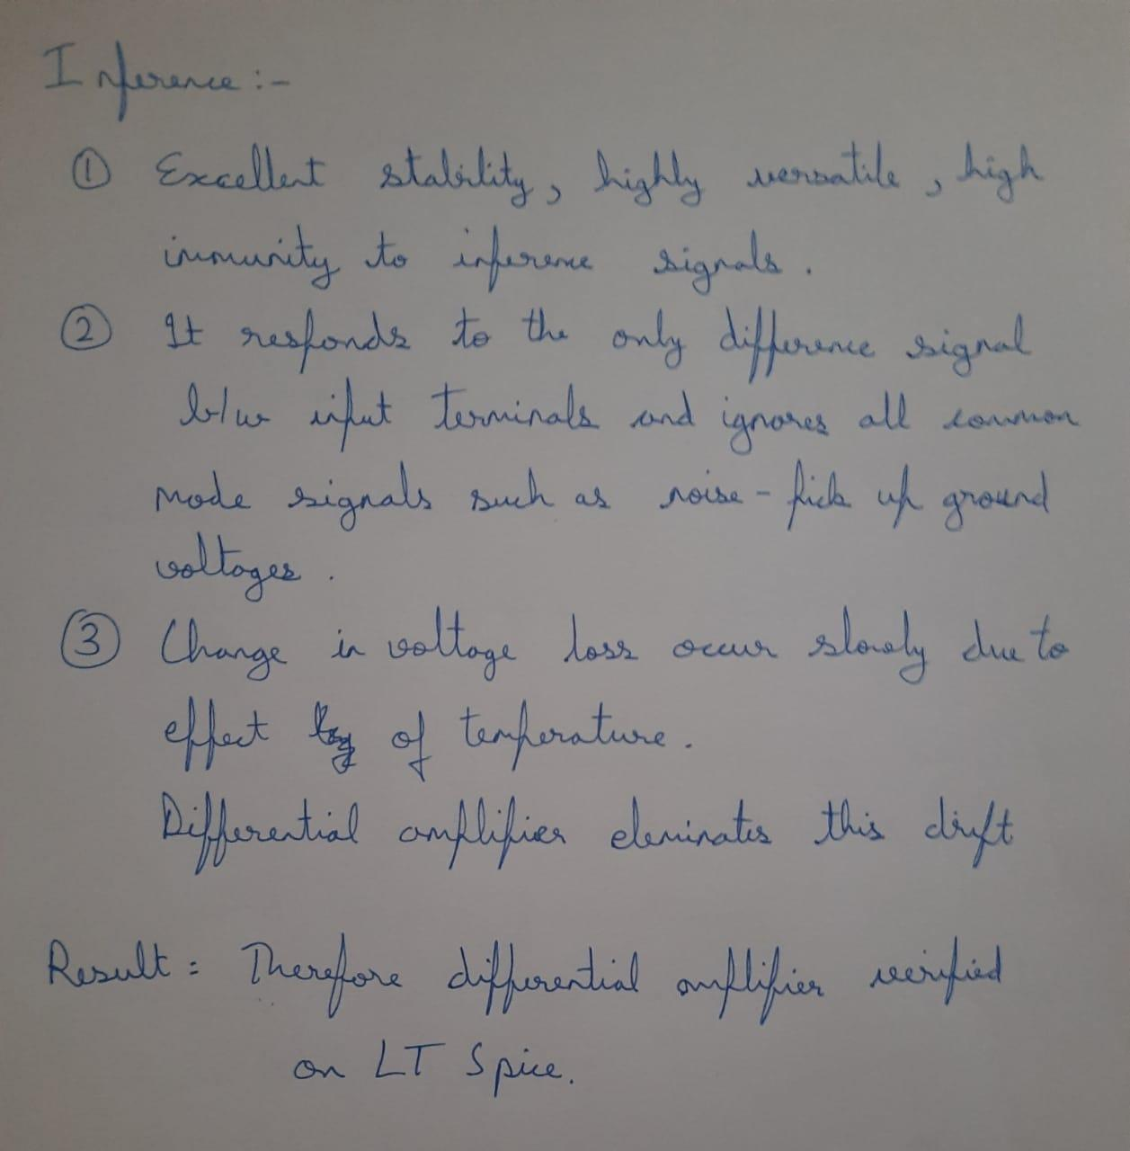

SCHEMATIC DIAGRAM:

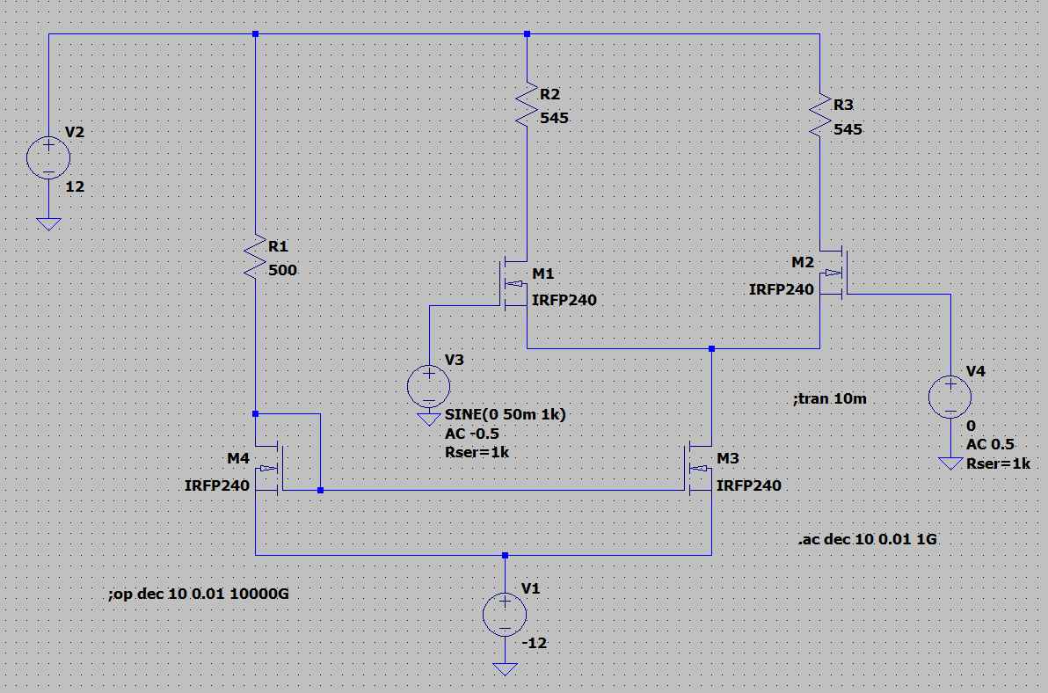

INPUT:

OUTPUT AC VOLTAGE:

TRANSIENT ANALYSIS:

EQUAL AND OPPOSITE:

